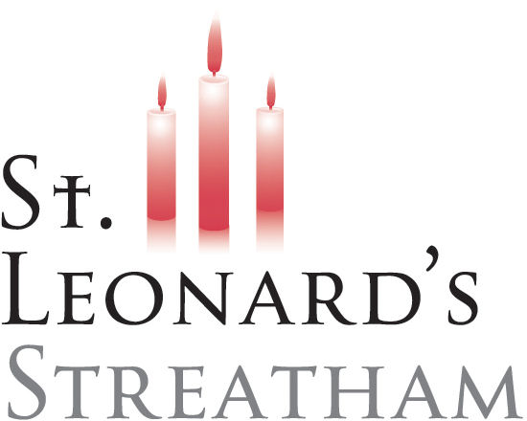
St Leonard’s Church, Streatham
Job Application Form
Children and Young People’s Lead

1. Personal Details
Full Name
Address
Postcode
Phone Number
Email Address
Right to work in the UK (Yes/No)

2. Faith & Church Involvement
Describe your Christian faith and journey
Current church (if applicable)
Your involvement / role

3. Relevant Experience
Experience working with children and young people
Relevant qualifications
Experience leading/supporting volunteers

4. Skills & Suitability
Why are you interested in this role?
How would you help CYP grow in faith?
Approach to relationships, volunteers, and programmes

5. Safeguarding
Safeguarding experience
Willing to undertake Enhanced Plus DBS (Yes/No)

6. Availability
Availability for required hours
Earliest start date

7. Additional Information
Anything else to support your application

8. References
Referee 1 (Name, Relationship, Email, Phone)
Referee 2 (Name, Relationship, Email, Phone)

9. Declaration
To my knowledge all the information given in this application is true.

Name
Signature
Date

